Keeping you up to date about your community
Diary Dates:
Tonight! Friday Night 15 April.. Pizza Oven Night at the community area, end of Kurrajong Lane BYO favourite pizza, drinks, nibbles. Oven will be hot and ready by 6.30pm. All welcome.
Monday 18 April Garden Club outing to Robyn & Denis Allen’s, Kensington Drive. Meet at 33 Wirrinya Ave at 9.45am for car sharing.
Thursday, 21 April. Thursday Lunch Club. Venue to be advised.
Wednesday, 27 April Next Board Meeting.
Monday 23 May. Garden Club to meet at Tina Norton’s, Orchard Drive.
Saturday 28 May. Social Committee BUS TRIP to ‘Brookfield Maze’, Myrrhee. Look for a detailed flier in your mailbox next week!
REMINDER: Water bills to residents due for payment by 30 April!
Board Members: Werner Vogels (Chairperson 57662896/0424751587), Caroline Robinson (Secretary 0434885099), Sheree McKenzie (Treasurer 0423079713), Gillian Anderson (Bushland/Parkland) 57662397/0411111830), Jodie Gottschling (Social 0419130445), Bob Shaw (infrastructure & Maintenance 57662773), Peter Ockenden (Water 0408313979)

Stage Two WATER RESTRICTIONS currently in operation. There is no water in the bottom two dams and we can’t pump from the 15 Mile Creek until May and only then if there is water flowing. Please follow the guidelines for minimal water usage. Hopefully it will rain soon!
News from your Board of Management
- Communication with the Board.. any resident wishing to raise an issue with the Board should contact the secretary, Caroline Robinson by email corobinson@csu.edu.au or phone 0434885099. Please note that general discussion posts to our Facebook site do not represent the views of the Hamilton Park Board, or any of the Board’s policies and procedures. On occasion this site may be used by a Board member to share official information such as water restrictions notices, working-bee reminders etc.

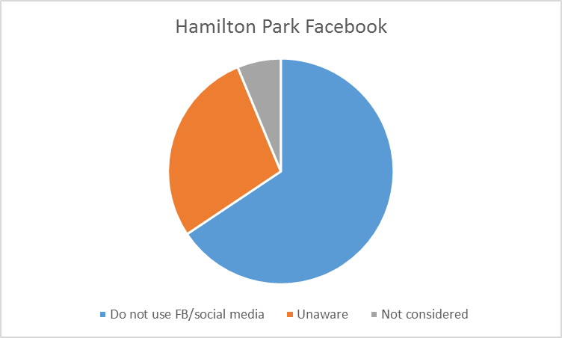
- The revised Social Committee members are now Tina Norton, Mel Williamson, Tracy Afflick, Nicky & Damian Feehan.
The newly formed Welcoming Committee members are Corrina Modderman, Wil & Bruce Meager.
- Working-bee Report.. 20 February.. 14 attendees. Tasks tackled include the removal from area 14 (at the end of Omar Close) of an introduced weed species, sallow wattle. Many ute loads and trailer loads (Frank Wellman won the prize for the most prunings that could be stacked on a trailer!) were taken to the pruning pile. Still more to remove. Rocks spread into drain at Henley Drive. Garden Club members worked on the garden in the centre of Henley Drive.
- Working-bee report 2 April. Although 38 families indicated on the recent survey their willingness to help at working-bees, only two residents were present. Jobs held over to the next working-bee.

RESIDENTS’ SURVEY REPORT Sharing knowledge and skills
Residents indicated their willingness to be involved in a broad range of activities related to the management of Hamilton Park. Residents appear to be most willing to support working bees, assist with weed management and tree planting, be rostered to check the water pump at 15 Mile Creek, and assist with water meter reading.
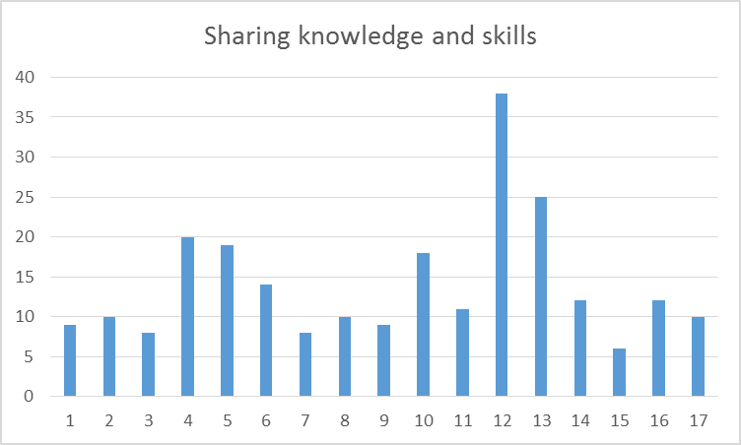
- Contributing to production of the Hamilton Park newsletter
- Assisting with maintenance of the Hamilton Park website
- Assisting with grant applications
- Checking the water pump at 15 Mile Creek
- Reading water meters on residents’ properties
- Maintenance of the Hamilton Park dams
- Maintenance of water mains and/or meters
- Development of a Water Policy for Hamilton Park
- Development of a Fire Safety Policy for Hamilton Park
- Development of a Welcome Pak for new residents
- Maintenance of Hamilton park equipment e.g. mowers; fire equipment
- Participation in working bees to maintain the common land areas
- Weed management and tree planting
- Feral animal management
- Road maintenance and signage
- Maintenance of the BBQ area and/or tennis courts
- Organising a local produce market

- More from the SURVEY REPORT.. the top two items for each theme from the 66 % of surveys returned.

Living in Hamilton Park
- Question 1: What do you value most about Hamilton Park?
Overarching themes | Residents’ comments | % of respondents
Space, peace and quiet | Space, peace and quiet  Large house blocks | 42.5% (34)  8.75% (7)
Bushland and nature | Natural assets/bushland  The birds/wildlife | 17.5% (14)  13.75% (11)
Sense of community | Great community  Safety and security | 20% (16)  11.25% (9)
Lifestyle | Walking tracks  Availability of water for gardens/dams | 8.75% (7)  8.75% (7)
Location | Location in NE Victoria  Proximity to Glenrowan and Wangaratta | 7.5% (6)  3.75% (3)

- Question 2: Please list three ideas for the improvement of Hamilton Park.
Overarching themes | Residents’ comments | % of respondents
Recreation and leisure | Playground for all ages | 12.5% (10)
Pets | Keep cats indoors at night/keep cats on their own premises | 10% (8)  3.75% (3)
Roads | Improve road quality borders/erosion/drainage  Widening of Henley Drive | 6.25% (5)  2.5% (2)
Building community spirit | More community involvement/activities  Regular newsletter | 5% (4)  2.5% (2)
Bushland/common land | Pruning pile open for longer/all year access  Picnic tables/seating in the park | 5% (4)  3.75% (3)
Water | Enlarge dams  Closer monitoring of water i.e. overuse;  ensure standard of water pressure; upgrade water filters | 3.75% (3)  1.25% (1)
Services | Gas supply  Town water/improved water supply | 3.75% (3)  3.75% (3)
Amenities | Produce shop/small general store/bar  Better undercover area at BBQ; recreation/multipurpose hall; portable community centre; clean toilets | 2.5% (2)  1.25% (1)

Social activities
Residents indicated a generally high level of support for diverse social activities:
- The Thursday Club (3rd Thursday of each month)
- The Garden Club (4th Monday of each month)
- Friday Night Social (BBQ area)
- Australia Day breakfast and awards ceremony
- Annual tennis event/social tennis
- Christmas party
- AFL Grand Final Day
- Informal progressive dinner
- Street party (at the BBQ area)
- CFA/Environment talks
The community’s input via this survey will assist the Board in determining an action plan to respond to residents’ ideas and suggestions to make Hamilton Park an even “greater place to live”. Thankyou to all residents who helped contribute to this survey.
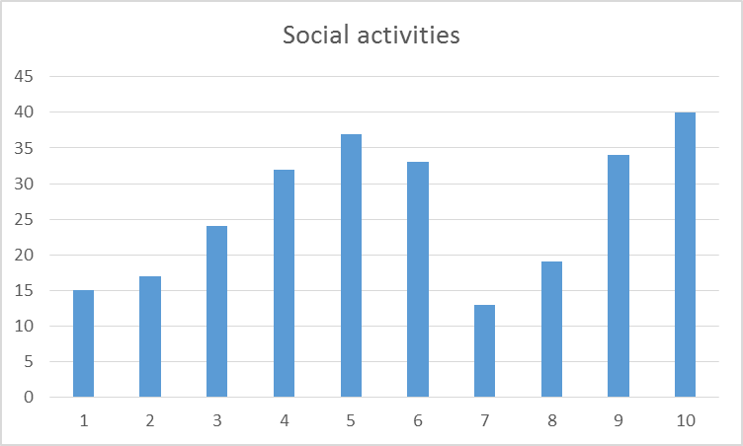
Other suggestions for social activities included:
- An annual ‘Welcome BBQ’ for new residents
- A playgroup/support group for young Mums
- A ‘Meet Your Street’ initiative
- A Bush Dance
- An annual Hamilton Park golfing day
- A bonfire night
- A kite festival
- Garage sales
Residents also contributed ideas for sporting facilities in the park including: upgrading of the tennis courts; installation of a netball/basketball ring at the tennis courts; provision of bike jumps for children; renewal of the golf practice range; enabling fishing activities for children; and the installation of soccer goals.
Editor’s note: Apologies for the lack of images from around the Park this month but the editor’s smartphone went for a swim in the kitchen sink and all photos have disappeared!
Dear residents of Hamilton Park,

Let me first state a huge thank you to all the people who have returned their surveys and shared their ideas with us - your recommendations for improvement and suggestions for improving the sense of community, organising social events and skills we can use to keep our Park a wonderful place to live. We had a good return rate and were certainly inspired and impressed by the candid feedback and dedication and willingness of so many in keeping Hamilton Park a great place to live. As we might have expected, communication was a major item, and so was community spirit. It means that with everybody’s input and effort we can rekindle the Social Club, looking at ways of getting more people involved in events and activities, but also looking at how to improve the Park, how we best communicate with residents and in what way. Of course, with so many great ideas that have come out of the survey, we can’t commit to them all, and even if we would like, we certainly can’t afford to implement all ideas and suggestions. We’ll try and be creative and innovative in a variety of ways and see if we can find alternatives or think ahead (long-term projection), accommodating some shared wishes in future budgets and the required savings for future needs. As we’re still receiving surveys, some early findings are presented in this Newsletter, but the final report is still a short time away. We, as the Board, certainly feel invigorated by the surveys and feedback and really want to thank all of you who have shared their ideas with us.
Autumn is a beautiful time of the year to walk through our gorgeous park, hike through the Warby Ranges and appreciate the beautiful surroundings we live in. As we haven’t had any rain for a long time, our water supply is scarce. It has meant we needed to implement Stage 2 water restrictions, so only handheld devices and no lawns to be watered. It is a fairly rare sight to see one of our dams empty, so you can imagine why we have to conserve the water we have and all be diligent in adhering to the restrictions.

You may have seen that the Pruning Pile now has a gate to plan access, as we want to make sure only residents of Hamilton Park use the pruning pile, in the way it is supposed to be used, for disposal of green waste, not plastic and all sorts of different rubbish like last year.
The Park is a place for us all to enjoy and appreciate. We need to look after the Common Land, so we conserve our beautiful environment.
Our Park requires that we collectively look after it. So see if you can join a working bee, help out with mowing, become member of the garden club, and question inappropriate use of our common facilities and land. That is all our responsibility.

Also, with over 100 families living in this unique community, opinions may differ and views expressed may not be held by everyone. That is absolutely fine, it is what makes a community strong, and it allows for diversity, mutual respect, tolerance, and certainly interesting conversations. If you want to communicate with the Board, send a letter or email addressed to the Board via the secretary, so we can respond via the appropriate channels.

Warmest regards,

Werner
Chairperson
Hamilton Park Board of Management

To – Hamilton Park residents From – Hamilton Park Board of Management

Subject - Dogs and Cats
References–1. Rural City of Wangaratta website on “Responsible Pet Ownership” 2. Rural City of Wangaratta, Community (Amendment) Local Law No. 1 of 2014. 3. The Rural City of Wangaratta Domestic Animal Management Plan (DAM plan). 15 July 2014.

Dogs and Cats on Other People's Property
If a neighbour asks you to stop your dog or cat coming onto their property you must do so. If they ask you more than once and your animal still strays you can be sent a Notice of Objection by the Council. If your dog or cat strays again after this Notice, you can be fined/prosecuted by Council.

Barking Dogs
Your neighbours can complain if your dog is often noisy or disturbs the peace unreasonably. A Council officer will discuss the problem with you and offer advice on what you can do about it. If the problem continues and they don't think you are making a real effort to stop the dog barking, the Council can prosecute and you may be fined.

Wandering Dogs
It is an offence to allow you dog to wander on its own outside your premises. Your dog must be securely confined - that is, the gates must be shut and the dog must be unable to leave the property.

Secure Confinement – Cats and Dogs
Your dog must be confined to your property both day and night, except when being exercised on a leash or under effective control. You must ensure confinement to your property. Fines can be imposed on the owner of a wandering dog.
Your cat must also be confined to your property, especially at night. This will keep it safe from accidents and cat fights. This also protects our native nocturnal wildlife.

Effective Control
Any dog or cat in a public place must be under effective control by its owner at all times. This can be by means of a leash, or in the case of dogs, under direct voice command.
Any Complaints can be made to Enforcement Department at the Wangaratta Rural City Council on 57 220 888.
The Rangers have stated that they would prefer first-hand information about Dogs and Cats and they prefer to first speak to the complainant, whose identity remains confidential under the Privacy Act.

[Type a quote from the document or the summary of an interesting point. You can position the text box anywhere in the document. Use the Text Box Tools tab to change the formatting of the pull quote text box.]

.

