Hamilton Park Board Members 2013/2014
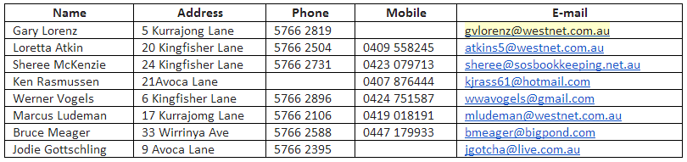

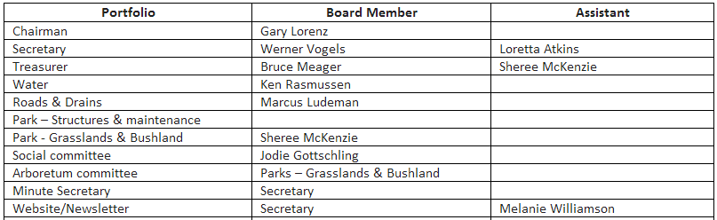
Board Meeting Notes

Hamilton Park Is ONLINE!
www.hamiltonpark.org.au
The website has the current newsletter, important dates, general information, photos of social events, who to contact in case of problems relating to Hamilton Park, a handy list of Hamilton Park residents and locals and the Services/Products they provide. Head online to have a look!
If you would like to receive your newsletters/information electronically or would like to contribute to the website send Melanie Williamson an email melanie@hamiltonpark.org.au
FOR SALE
The Board has some items for sale……
Concrete Pipes - 2.4m Long $100.00 each and 1.2m Long $ 60.00 each. Contact: Gary Lorenz for further details.
Toro Ride On Mower. An old tractor, slasher and grader blade.
Should you be interested in the Toro or the tractor drop a line to The Secretary PO Box 647 Wangaratta with an offer. The Board will consider the offers and be back in touch with you.
Working Bee
19 people attended the last working bee in October. Jobs completed included continuation of gravel path along Henley Road, pruning of trees along roadsides and turning circles, repainting of 40 km markings on road, large amount of whipper snipping and weeding, and tennis court maintenance.
It’s great to see the kids using the new path on their way to and from the bus stop..
Next One Is…
Sunday December 8th from 8.30am
Please consider giving an hour or two of your time to help in the upkeep of the Park.
The BBQ and refreshments following the work is always welcome.
Pruning Pile
The pruning pile has been relocated onto the top of the dirt pile near the bottom dam.
It will not be opened until autumn and then only on Working Bee days, or as directed by the Board.
Driving within Hamilton Park
The Board is responsible for the upkeep of the Parklands. Pease assist by driving only on bitumen roads. Driving off the road damages the vegetation as well as being a danger to kids, walkers, dogs and cyclists
Please access your properties only via the road.
Should you see vehicles off the bitumen, please remind drivers to respect our parklands
Special General Meeting
To discuss The Fire Management Plan will be held on February 22nd at 10.00 am at the Hamilton Park BBQ area.
An updated copy of The Integrated Fire Management Plan will be delivered to all residents.
Australia Day Celebrations
As well as the Christmas Gathering and the Fishing Competition advertised in the last Newsletter the Social Committee is organizing The Australia Day Breakfast to be held at the Hamilton Park BBQ area on January 26th.
Social Notes….
A warm welcome to Paul and Gillian Derezyckyj who moved into Orchard Drive a month ago. Gillian wrote to the Social Committee saying… “Last week I was enjoying my garden early morning and spotted a Regent Honeyeater in a grevillea. On reporting the sighting to the Regent Honeyeater project, I got an amazing response, with the head of the project driving from Melbourne to photograph the 2 birds which had been part of the recent captive breeding release program”.
For more information on the Regent Honeyeater download the flyer on the Website.
CHRISTMAS HAMPER!
Get your loose change ready….The Social Club will have the Christmas Hamper ready to sell tickets this week $2 each or 3 for $5
HAMPER DONATIONS Call Nicole on 57 66 2194 or Melanie 0421118126 we can pick them up!
XMAS PARTY this Saturday 6.30pm
Don’t miss the Hamilton Park Christmas Party! Kids, the movie selected is Santa Clause…bring your bean bags, sleeping bags and pillows.
PARENTS – From 6.30pm kids can enjoy a sausage and a can of soft drink for $2.50 at the Christmas Party.
Adults BYO food and drinks for a BBQ. SANTA ARRIVES 7.30pm with Lolly Bags and Icy poles!
WRONG DATE! The fishing competition said in the Social Newsletter it was on the 9th January…It is Saturday 11th of January
The Hamilton Park Garden Club end of year gathering was held at the BBQ area on Monday 25th November at 10am.
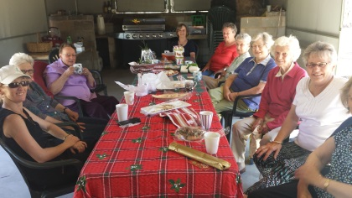
Chris Cringle gifts were exchanged and lots of yummy food to be had in the lovely company of like-minded gardeners
Love Gardening? Then don’t hesitate to come along to the next meeting held in February on the 24th…..Venue to be decided and we’ll let you know.
Wil and Bruce Meager’s house welcomed the Hamilton Park Garden Club in all its Spring glory when we attended in September.
Simply stunning….
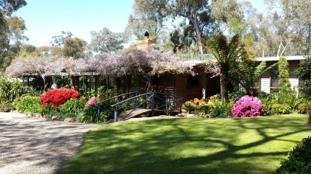
After a tour of the garden we all basked in the early morning sunshine while enjoying a delicious morning tea.
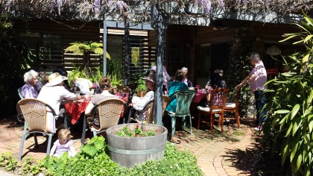
From the Hamilton Park Board and Social Committee we wish you a very Merry Christmas and safe travels if you plan on going away.

