Diary Dates:
Keeping you updated about your community
Friday Night Club Friday evenings at the BBQ shed – 6.30pm BYO everything.
Sunday 6 December HAMILTON PARK CHRISTMAS PARTY see photos
Wednesday 20 January 2016 next Board Meeting
Thursday 21 January 2016 next Thursday Club lunch will be at the Lake Mokoan Hub Cafe.
Tuesday 26 January Australia Day Celebrations
Monday 22 February next GARDEN CLUB outing. Venue 33 Wirrinya Ave.
Next WorkingBee to be advised
Board Members: Werner Vogels (Chairperson 57662896/0424751587), Caroline Robinson (Secretary 0434885099), Sheree McKenzie (Treasurer 0423079713), Gillian Anderson (Bushland/Parkland 57662397/0411111830), Jodie Gottschling (Social 0419130445), Bob Shaw (57662773), Peter Ockenden (Water 0408313979)

[Type a quote from the document or the summary of an interesting point. You can position the text box anywhere in the document. Use the Text Box Tools tab to change the formatting of the pull quote text box.]

Board Meeting Dates for 2016: 20 January; 17 February; 16 March; 18 May; 15 June; 20 July; 21 September; 19 October; 16 November.
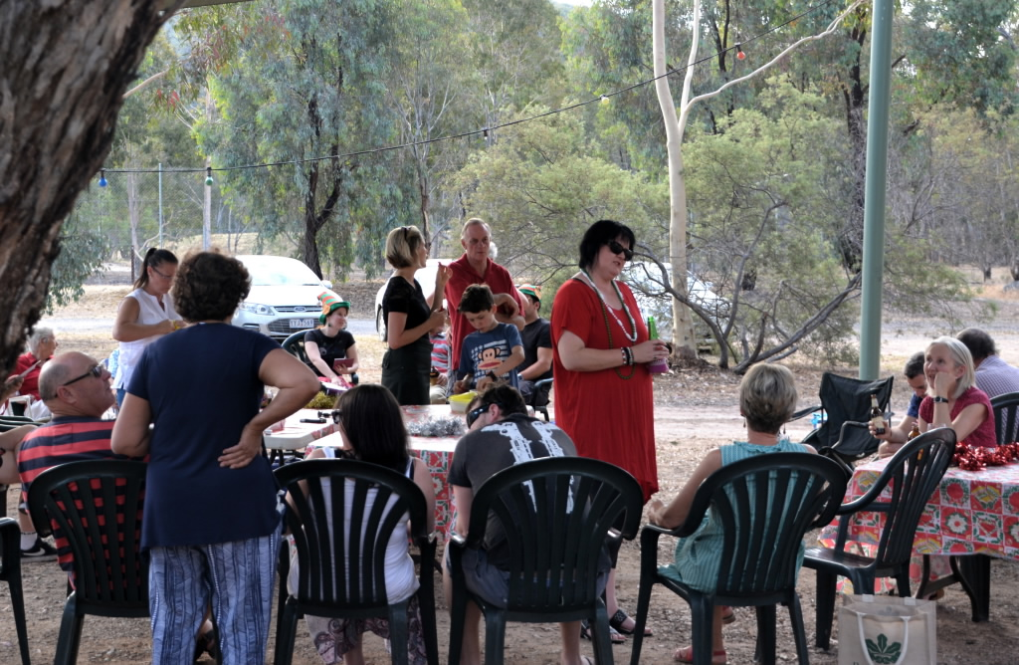
Christmas Party held 6 Dec. Where’s Santa?
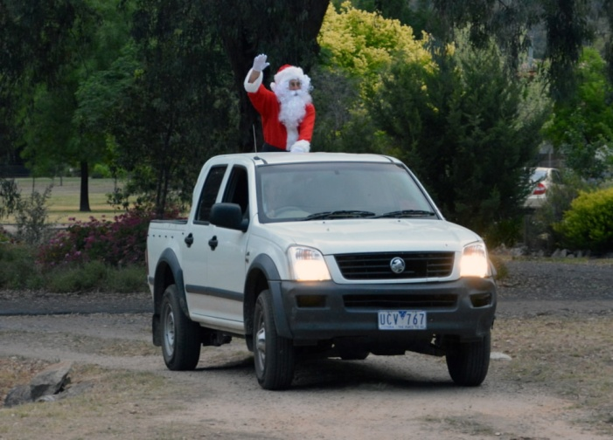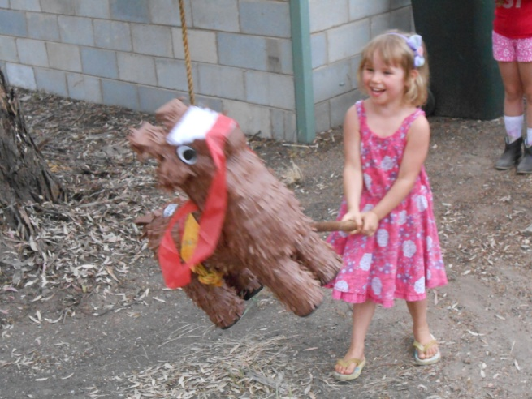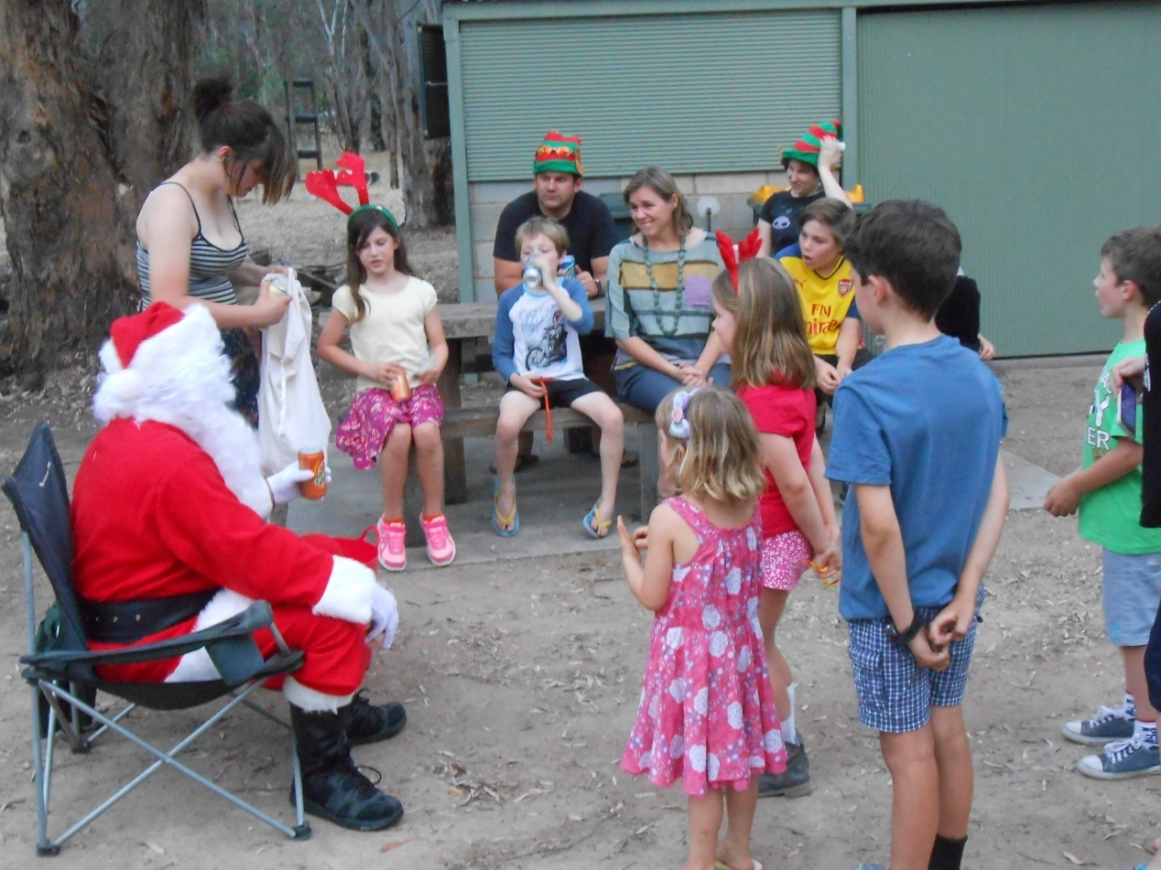
Hit that piñata Luna!
What? No reindeers?
STAGE ONE Water Restrictions in Hamilton Park and Grants Estate – Please don’t waste water!
We have water restrictions all year round. We now need to go to STAGE ONE restrictions so that we will have sufficient water for residents use and for fire fighting in the Dick Hamilton dam (the “top dam”) for the entire summer fire season. We have adopted the same rules as North East Water for consistency across the region.
- Residents can only use a manual watering system on alternate days (including lawn areas).
- If your property number is odd, then you are allowed to water on the odd days of the month (so even numbers to water on even days) between the hours of 6am and 8am & 8pm and 10pm.
- An automatic watering system can be used, which operates only as required within the hours of midnight and 4.00am on alternate days.
- You can water your garden and lawn with a hand-held hose (fitted with a trigger nozzle), watering can, or bucket at any time.
- All residents can water between these hours on the 31st of each month.
- If you are using your property grey water, a bore or well these rules do not apply.
These restrictions start now. We may need to move to Stage 2 in the near future.
Any questions call Peter on 0408 313 979

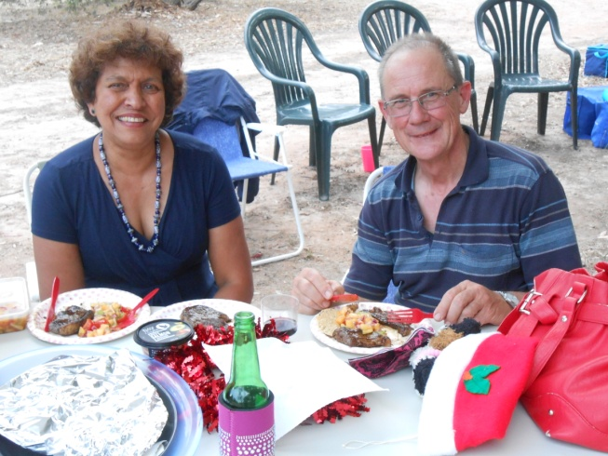
Did you know?
- Congratulations to Chanelle and Adam Gaspari on the arrival of their son, Liam, who is now two months of age.
- Welcome to new resident Anne Ford, who moved into her home in Warby Range Road in late October and to Kerri Price & Luke Croxford in Warby Range as well. WELCOME!
- Hire of our BBQ area can be arranged through Melanie (0421118126).. $20
- The Wisener family in Orchard Drive were the lucky winners of the recent wood raffle.
- Fire hydrants are not for residents’ use. They are maintained regularly - checked and flushed – for Fire Brigade use only.
Suzie Don Leonard won the Christmas hamper!

Some more news from your Board of Management
- The maintenance levy to residents has not increased since 2011. The Board is proposing a moderate increase for 2016.

- Board members will be visiting residents to seek feedback on – ideas for Hamilton Park development; preferred communication method; development of a volunteer register; identifying skills, knowledge and business profile of HP residents; future planning.

- The Working-Bee held on the 21 November was well attended with most jobs completed. It is great to see residents giving their time to maintain and improve the common land and facilities at the Bracken Shed/BBQ area for the benefit of all residents. Volunteers mean we do not have to pay contractors to do these jobs! Working-bees are also a great way to meet other members of our community.

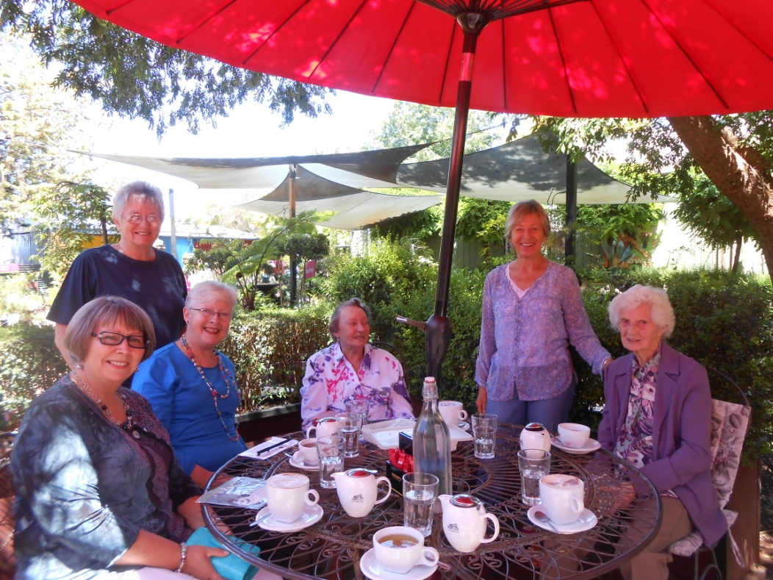
GARDEN CLUB members at their end of year break-up at the Benalla Green ‘n Grow Nursery.
L to R:
Carole Ockenden, Tina Norton, Rewa Wallace, Joan Rowlands, WilMeager and Marion Pearce.

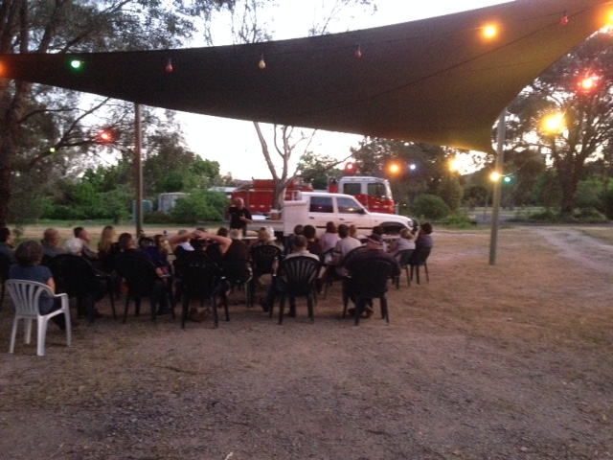
Fire Ready Meeting held 14 October .... There was a good roll up of residents to hear Glenrowan Fire Brigade member, David Stone, remind everyone to be ready for the fire season. Residents came away with much information to prepare for this summer. More information is available on the CFA website.
Adele Webber and her reindeer antlers at the Xmas party.
Merry Christmas everyone and may 2016 bring much health and happiness!

Hamilton Park Common Land Management Report

Some good gains have been made during 2015 in management of the HP common land, with preservation of areas of native grassland and woodland. More work is required to preserve the delicate balance between conservation, fire safety and providing recreational areas for residents.
Mowed open spaces
- Areas of native grassland are much less dense and are mowed once per year to allow the grass to seed and survive. Over-mowing and soil disruption will damage this environment and allow weeds to take hold.
- Introduced grasses are much dense and need to be mowed more frequently.
Woodland
Comparison of the woodland photos shows how much damage and loss of habitat can be caused by the inappropriate broad scale use of herbicide sprays. Any spraying of common land areas must be carried out in consultation with the HP Board, using Roundup Biactive to prevent water contamination and targeting specific species to minimize bushland damage.
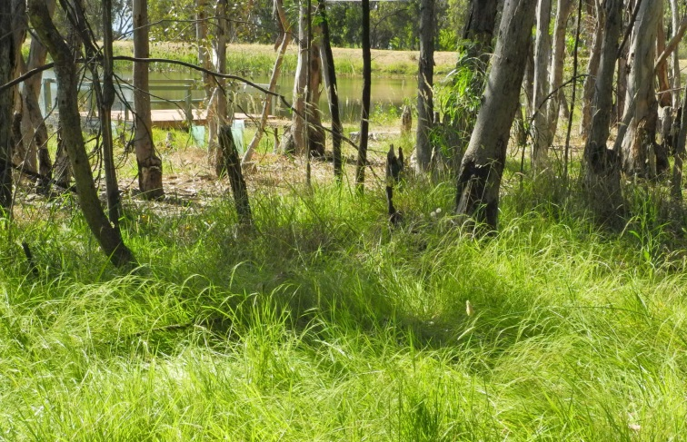
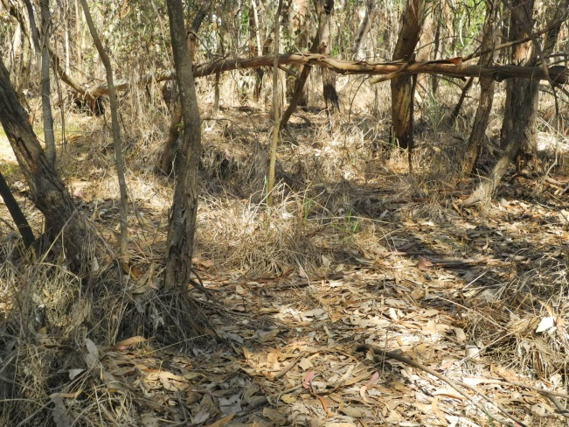
Zone 7 Selective spraying to remove introduced grasses leaving native weeping grass. Decreased fire fuel. Nov 2015
Zone 14 broad scale spraying. Increased fire fuel. Nov 2015

- Residents are reminded not to create burning piles on HP Common Land.
- Because Hamilton Park & Grants Estate are zoned residential within The Rural City of Wangaratta, NO burning off is permitted without a permit.

Board Chairperson’s Report
Dear residents,

Summer has well and truly arrived, and that means Christmas is around the corner! Only a few weeks ago on Sunday Santa visited Hamilton Park again and was happily giving out lolly bags to all children and grown-ups alike. A good turn-out for this yearly event meant that there was plenty of food and refreshments to go around, and the Social Committee had even organised a pinata! Great to see the kids having a go at it.
The fact that summer is here also means that our gardens and vegie patches are in need of some water, and to make sure that we will maintain enough water in case of dire need, we have some much needed water restrictions in place. Please make sure you read what they are and act accordingly! Peter Ockenden has spent a great deal of time on the preparation of these restrictions (which are an amended version of the North East Water ones) and the Board really want to emphasise the need to adhere to them. If you happen to pass the lower dam, you can see how low the water level already is with most of summer still ahead of us! So treat water with respect.
Also, on a similar note, fire hydrants are for emergency purposes only.
At the AGM in October, we said goodbye to Greg George, who resigned from his position on the Board. I, on behalf of the Board, would like to take this opportunity to thank Greg for his contribution and commitment to the Board over the course of last year. The AGM also saw the return of Bob Shaw to the Hamilton Park Board, which is fantastic news for our community. Immediately, Bob put forward a proposition to develop and circulate a survey to residents, asking them about best ways to communicate with them and ideas and suggestions to put to the Board, but probably most importantly, inquiring with residents about their skills and how to best capitalise on those, to the advantage of the wider HP community. So expect someone (a Board member) to knock on your door in the next few months, or alternatively check your mailbox, because we are keen to hear from you about your opinions and constructive feedback.
Since the AGM in October, the Board has already had its first meeting in late November in its current make-up, and this meeting had the major purpose of reviewing the Common Land Management Plan. In this Newsletter, you’ll find some topics and items that are reviewed and the Board would like to bring to your attention. We are on the right track but there is certainly room for improvement. Our common areas are for all to enjoy, and for all to look after. The primary purpose of the Common Land Management Plan is to have a guide and a tool for us all to refer to and implement, as much and as diligently as we possibly can. That way we can all enjoy our beautiful and quite unique surrounds, now and in the future. Consequently I find it quite disturbing that there is a whole patch of common land (Area 14, see photo in this Newsletter) that has been sprayed in an effort to ‘eradicate’ weeds, but as a result has destroyed everything it came in contact with. It now represents fire fuel more than well-maintained common land. Please refrain from destroying our beautiful common land and surrounds, despite your initially best intentions. If you are unsure, ask a Board member or someone from the Gardening group. They are happy to help and assist.
On a personal note, I am pleased to have been re-elected at the last AGM and have another year ahead of thinking about the Park, how to best communicate with residents, how to get you all involved and motivated and how to best maintain and further develop the beautiful place we all love and live in. I always remind myself that we are so lucky to live here when I go for a walk in the evening around the dams and through the Park, just stunning, truly special.
With that as my main reflection for this Newsletter, there is only one thing left for me to say and that is me, on behalf of the Board, wishing you all a fabulous and inspiring 2016!
May 2016 be the year of a strong community sense, based on participation and belonging. Have a safe and enjoyable festive season!

Werner

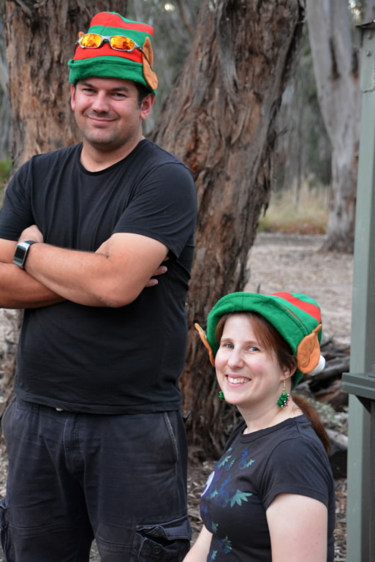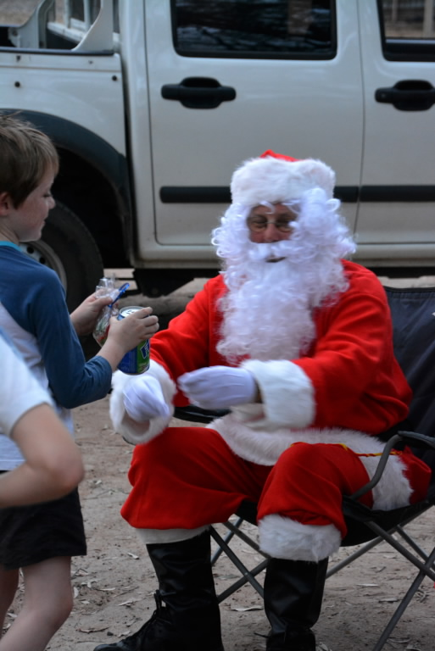
Some more pics from the Xmas party!





