Diary Dates:
Keeping you updated about your community
Friday Night Club Friday evenings at the BBQ shed – 6.30pm BYO everything.
Thursday 16 April The Thursday Club Pub meal SYDNEY HOTEL 12noon.
Sunday 19 April Next WorkingBee 9am, Meet at BBQ area.
Monday 20 April Garden Club 10am meet at Tina Norton’s & then to Sheila Broydell’s, Wangaratta
Thursday 30 April Water payments due on or before this date.
Saturday 2 May Turquoise Parrot Nest box building project. 10am-2pm All materials and BBQ lunch provided at BBQ area. Contact Gillian 57662397 for any further details.
Thursday 21 May next Board Meeting (Future meetings 23 July, 24 September, 26 November)
Board Members: Werner Vogels (Chairperson 57662896/0424751587), Caroline Robinson (Secretary 0434885099), Sheree McKenzie (Treasurer 0423079713), Gillian Anderson (Bushland/Parkland 57662397/0411111830), Jodie Gottschling (Social 0419130445) Greg George (Infrastructure/Maintenance 57662732/0478274014), Peter Ockenden (Water 0408313979)

[Type a quote from the document or the summary of an interesting point. You can position the text box anywhere in the document. Use the Text Box Tools tab to change the formatting of the pull quote text box.]
Dear residents of Hamilton Park,

Another season, another Newsletter! What a beautiful time of year to walk through our lovely park and enjoy the variety of flora and fauna around us. Absolutely one of my own favourite times of the year. Also a time of the year where garden maintenance is high on the agenda for many. Luckily for us, we can now take our garden clippings to the pruning pile on Henley Drive, what luxury! Just remember to not dump any hard waste: keep it green!
A few months have passed now since the last Newsletter and a few highly successful events have been enjoyed by quite a few of you. It has been an absolute testament to Shirley and Mike Wilson to see so many residents attend their farewell, and it is an example of how community-minded the Wilson’s have been, what they have meant for the Park, for the residents, and how sorely they will be missed in so many different ways. The good thing these days is that they can keep in touch and up to date because of Newsletters, visits, the Facebook page or the website.
Last board meeting, Mel Williamson visited us to talk about the website, what we want it to look like, what stories we want to share and what information to put on their for people to browse through. So undoubtedly over the next few months you’ll see plenty more photos and stories of events and activities, more information and more recent updates of what is happening around this great place to live.
There are two other events I’d like to mention that I thought were hugely successful, one of them the CFA Information workshop held in February. This event was attended by 22 residents and was an interactive way for residents to engage in a workshop led by CFA, local fire captains and Wangaratta Council representatives to talk about fire plans and emergency preparedness, gathering information and spending an evening learning about many things related to fire, fire behaviour, planning, etc. The good thing is that we want to organise such an event on a yearly basis so we can all stay informed.
The other one was the opening of the bike path connecting Hamilton Park and Glenrowan, which was a reasonably wet and thunderous event, but nevertheless absolutely worthwhile mentioning. It is great to see so many people running, walking or riding their bikes on the path and putting it to good use. What better sight than school children riding their bikes to school using the path, a great achievement! Thanks to Sheree McKenzie and others for their tenacity in convincing Wangaratta Council to deliver on the goods.
As you may all know, we live in a place with a hugely intricate water-system, that requires regular maintenance and repairs. The board is very lucky to have Peter Ockenden as a very dedicated and knowledgeable member on the Board, looking after the portfolio of water. The board is committed to explore and seek some external expertise to audit our water-delivery system and also prioritise some of the much-needed repairs. Timely renewal and educated repairs will save money, whilst we look to plan ahead to avoid being caught out and reactive.
As always, the Board is very keen to hear from you about what is on your mind, how you believe we can all collectively work towards maintaining and even improving the park around us, which truly is a great place to live. Talk to individual Board members about how you can contribute and share your expertise and skills, so we can all benefit and appreciate the effort that we all put in.
Your first opportunity will be this Sunday, 19 April, during the working bee. I hope to see many of you there!

Werner Vogels
Chairperson

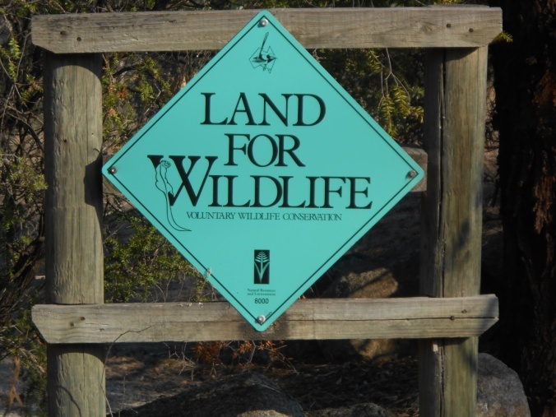
Free roaming feral and domestic cats kill native wildlife. Cat traps can be borrowed from the Rural City of Wangaratta offices (you need to book on 57220888) to assist with controlling “stray cats on private property without permission”. Cats caught on your property can then be taken to the RSPCA /Municipal Pound in Connell St, Wangaratta or the ranger will collect.
Hamilton Park – Land for Wildlife

Reminder to all residents..
Water restrictions apply all year round at Hamilton Park.
• No sprinklers or watering systems between 10am and 5pm;
• No hosing of paved areas and other impervious surfaces, except in an emergency situation; and
• The compulsory use of a bucket or trigger nozzle on hoses when washing vehicles.
....Also be aware of current fire restrictions (current fire restrictions lifted 1am, 13 April).

....Pruning pile (alongside bottom dam, entry opposite Omar Close) is currently OPEN for Hamilton Park residents.
Garden waste only – NO HARD WASTE to be dumped.

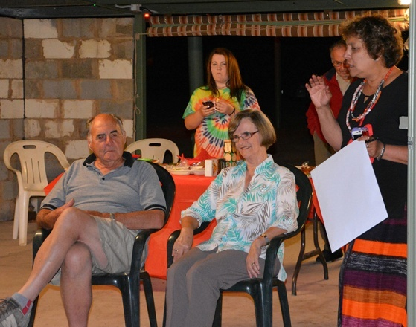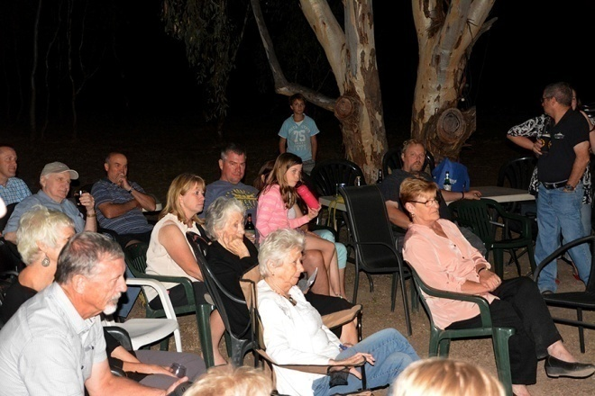
Wilsons’ Farewell Some of the well wishers included Brittany Gibbs, Suzie Don Leonard; Scott Williamson & Brett & Laura Webber; Mel Williamson & Annie Gibbs; Finn Vogels; Ron Taylor & Rob Parsons.
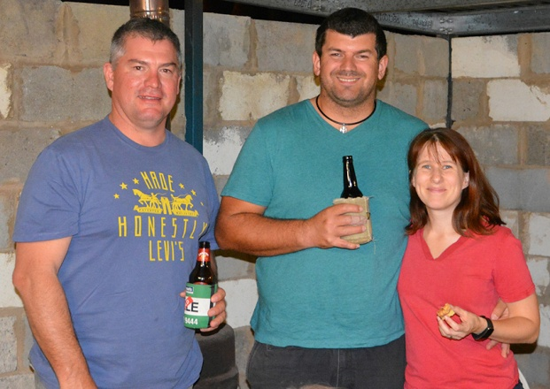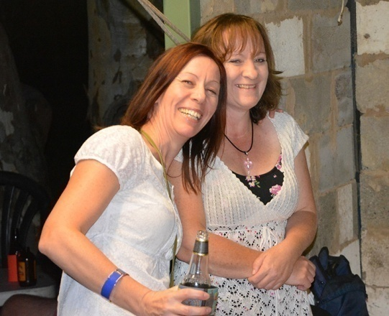
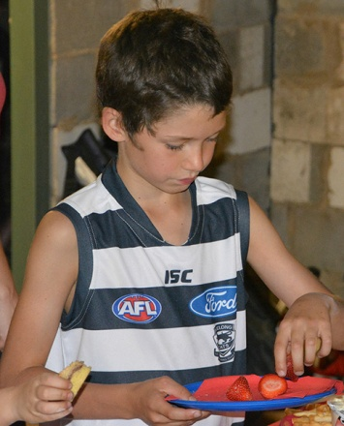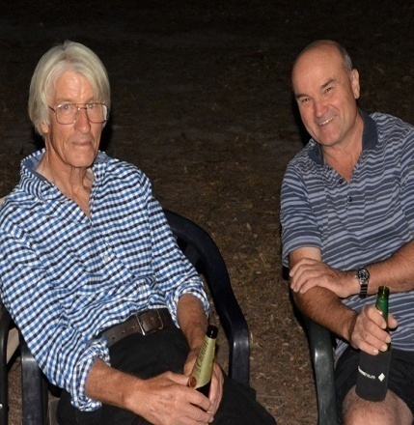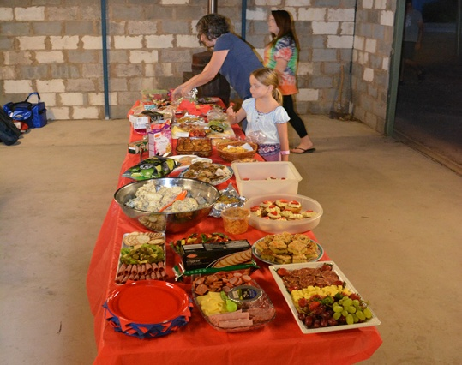
THANK YOU HAMILTON PARK

We would like to thank the wonderful community of Hamilton Park for the fantastic night we had on the 14th March. We were overwhelmed by the way people felt about us leaving. It was so great to see so many people come along to wish us well in the next chapter of our lives.
Thank you also for the Bunnings vouchers which was a first for me as they are usually given to Mike! I am looking forward to getting plants for our new garden and will always remember where they originated from.
A very big thank you to our dear friend Suzie for organizing the night, she did a great job.
Living in Hamilton Park has been part of our lives for so long. It has been a beautiful place to live and bring up our family. We have had some amazing times and made some lifelong friends. Being part of a close knit community has given us a great sense of belonging, which is important to us both.
Thank you all once again, please keep in touch and you are all very welcome to visit us any time.
Shirley & Mike Wilson

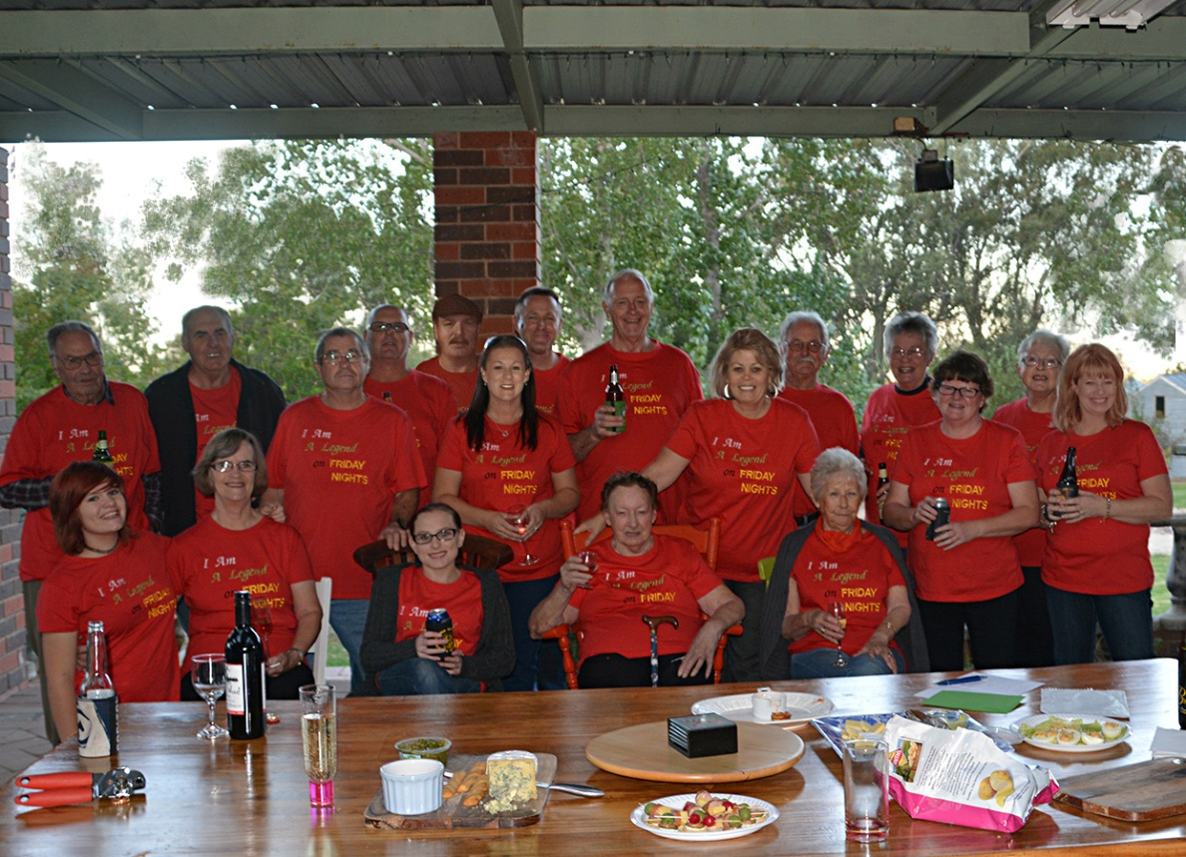
Another farewell to Mike and Shirley – this time it was the “Friday Night Legends”!
Rear – standing: Jeff Rolands, Mike Wilson, Marcus Ludeman, Tony Kosch, Ken Rasmussen, Nicole Ludeman, Damien Feehan, Steve Wallace, Tracy Afflick, Len Greskie, Tina Norton, Julie Kosch, Rewa Wallace & Nicki Feehan; Front – seated: Belinda Palmer, Shirley Wilson, Renee Kosch, Joan Rolands (The original Friday Night Legend) & Joyce Greskie.
D i d Y o u K n o w ?
- That you should have received your accounts for water usage for the last six months! (Thanks to our meter readers: John Del Zoppo, Doug McKimmie, Tina Norton, Robyn Coles, Marcus Ludeman, Wil Meager, Terry Wisener & Ed Garratt).
And talking of water .. Peter Ockenden is in charge of the water portfolio at the Board level and has found that maintenance and improvements to the system requires much time and plumbing/engineering skills. He would appreciate some residents’ assistance, especially with the skills to tackle minor plumbing repairs, fix meters (then we don’t have to employ plumbers) and also back-up helpers to cover Peter’s absence from the park to monitor the dam pumping operation when required.
- Your ideas are wanted for tasks to be tackled at working-bees .. please contact Board members Gillian or Peter with your suggestions.
- A BIG WELCOME to new residents to our park – John & Enza Rumble (Mistletoe Lane) and Laurence Brown & Zuzanna Lelito (Omar Close).
- Hire of BBQ area for birthdays, etc .. Contact Mel (0421118126) to book.

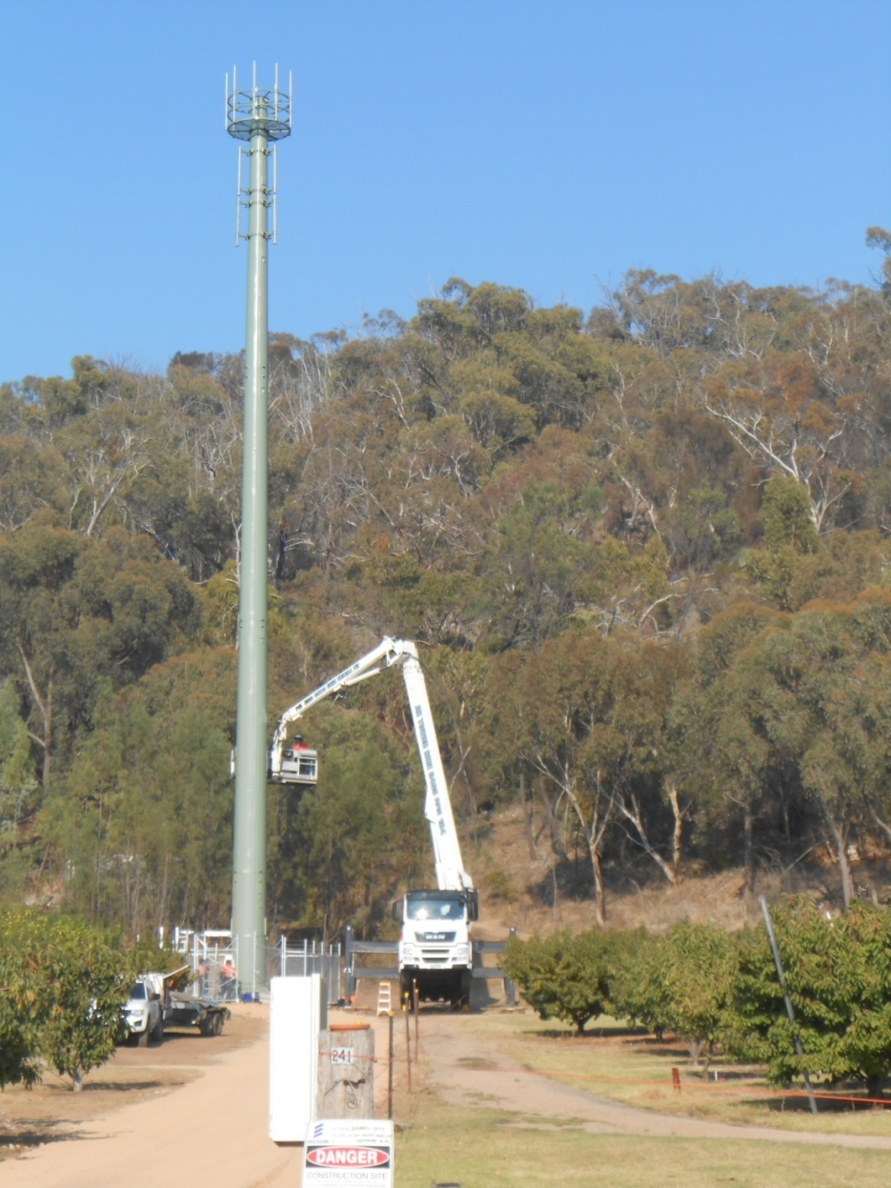
Have you noticed that the northern section of Orchard Drive has now been sealed? What about the tower that was erected recently at the top of Henley Road. Apparently it is for the NBN and connects with a tower at Brown Bros in Milawa.
Thankyou to all residents who have contributed to the newsletter. The newsletter is published after every Board Meeting (ie usually every second month). The editor is always looking for articles and photos. Please send to bmeager@bigpond.com One suggestion is to have a FOR SALE section in our newsletter so residents are invited to send in their adverts by the end of May for the next edition of the newsletter to be published early June. There is also a “for sale” section on the “Hamilton Park – A great place to live” Facebook Group page.

Hamilton Park – A Great Place to Live!
https:www.facebook.com/groups/690715957702113

.

